Transportation of Cylinders
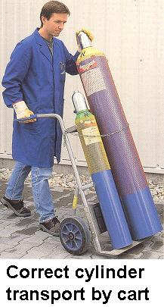
- Cylinders must be transported on wheel carts with retaining straps in an upright position.

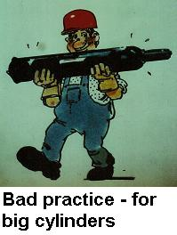
- A cylinder cart should always be used. Does not drag, roll, or slide cylinders.
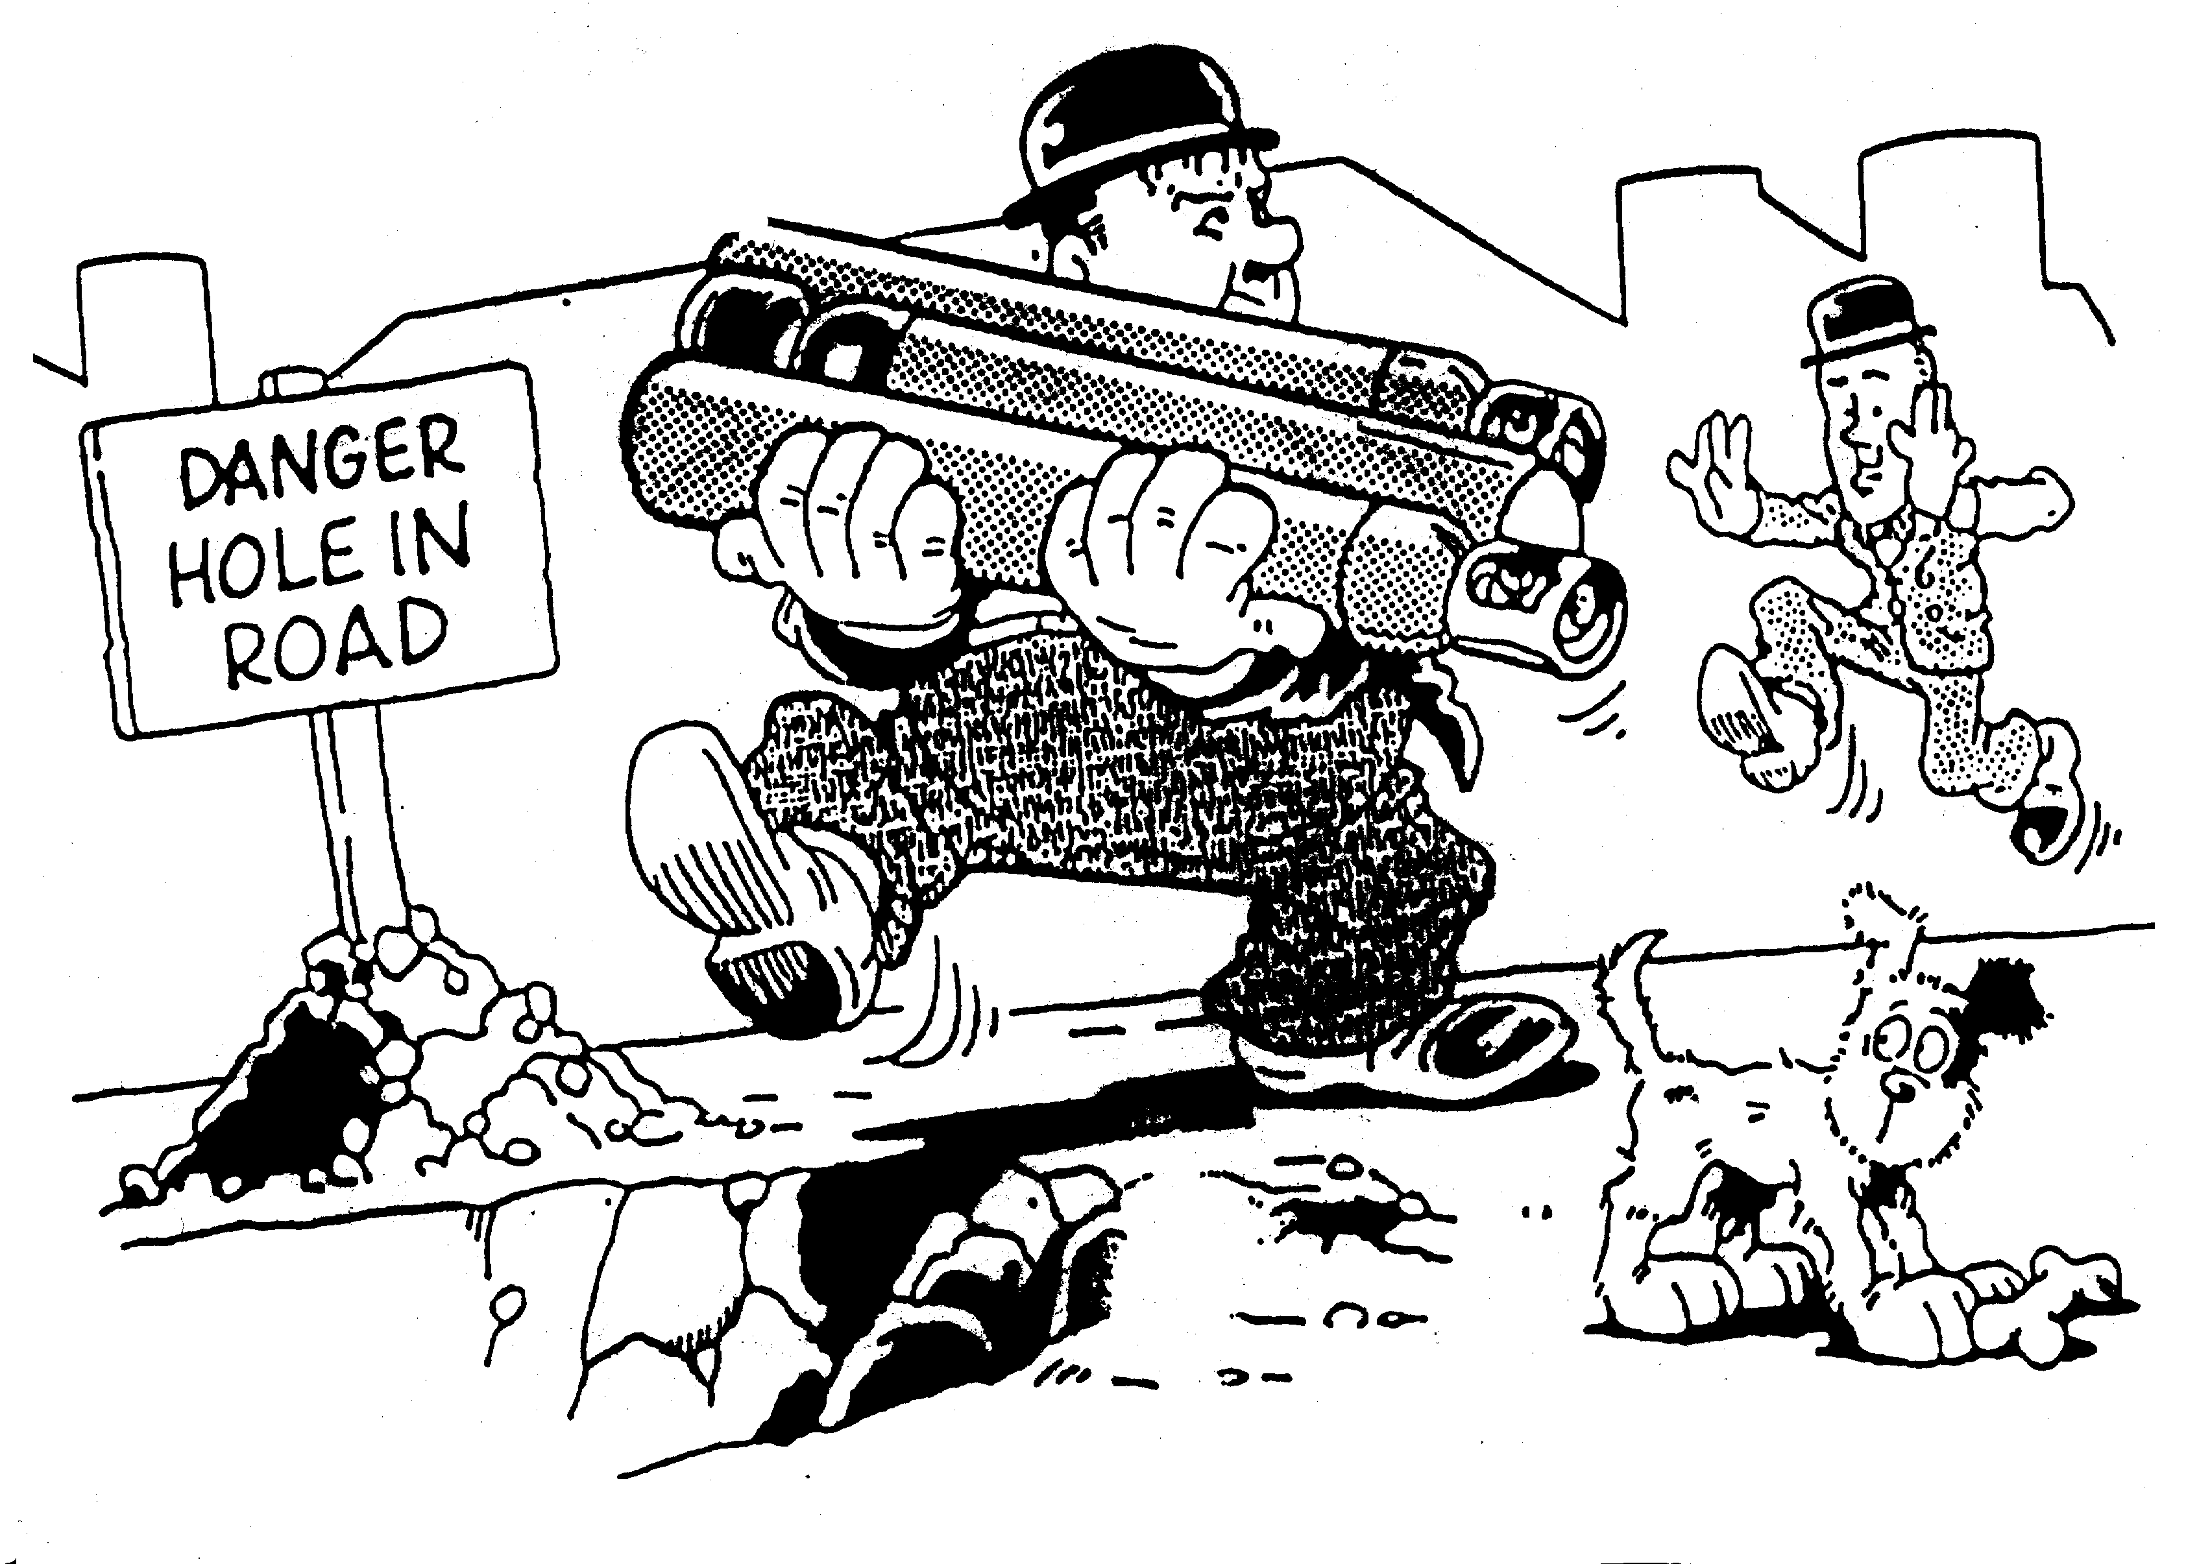

- Wear proper PPE: Close toe shoes, lab coat, and safety glasses.
- Do not drag or roll a cylinder with its valve cap.
- Make sure valves are tight and valve caps are secure before transportation.
- Cylinders should not be transported without a valve cap. The valve cap should be screwed down on the cylinders neck and securely tightly.
- Cylinder should not be transported with regulators attached.
- Never ride in an elevator with a compressed gas cylinder. Have 1 person send the elevator with the cylinder in it by itself and have another person go the floor where the cylinder is going to receive the elevator.

